Multiple-choice section – choose the correct answer

Question 1 [9.1]

Which of the following is not a quadratic equation?

**A** *y* = *x*3 + 3*x* – 7 **B** *y* = -5*x*2 + 1 **C** *y* = 2 – *x*2 + *x* **D** *y* = 2*x*2 + 3*x* – 5

Question 2 [9.3]

To obtain the graph of *y* = *x*2 – 2 we translate the graph *y* = *x*2:

**A** 2 units to the right **B** 2 units to the left **C** 2 units down **D** 2 units up

Question 3 [9.1]

The graph is an example of:

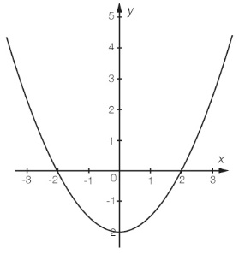

**A** a hyperbola **B** a circle **C** a parabola **D** an exponential

Question 4 [9.3]

The dilation factor for *y* = 3*x*2 – 1 is:

**A** 2 **B** -1 **C** 3 **D** 

Question 5 [9.5]

If the exponential graph *y* = 4*x*  is translated 2 units to the left and 1 unit up, what would be the new equation?

**A** *y* = 4*x**–* 2– 1  **B** *y* = 4*x* + 2 – 1  **C** *y* = 4*x –* 2 + 1  **D** *y* = 4*x* +2 + 1

Question 6 [9.2]

The solution to *x*(*x* + 5) = 0 is:

**A** *x* = 0, 5 **B** *x* = -5 **C**  *x* = 5 **D** *x* = 0, -5

Question 7 [9.7]

If *y* is inversely proportional to *x*, *k* = 50 and *x* = 10, what is the value of *y*?

**A** 10 **B** 40 **C** 50  **D** 5

Question 8 [9.4]

What is the radius of the circle with the equation *x*2 + *y*2 = 36?

**A** 36 **B** 6 **C** 9 **D** 1296

Question 9 [9.6]

If *m* is directly proportional to *l*, then the equation of this relationship can be written as:

**A** *m* = *kl* **B** *m* = *l* **C** *m**l* **D** *m* = 

Question 10 [9.5]

Which of the following equations will not graph a hyperbola.

**A** *xy* = 5 **B** *y* = + 3 **C** *y* = **D** *y* = 4 –



Multiple-choice results: \_\_\_ / 10

Short answer section

Question 11 7 marks [9.1]

For the equation *y* = -*x*2 – 6*x* – 5:

**(a)** Complete the table of values.

|  |  |  |  |  |  |  |  |
| --- | --- | --- | --- | --- | --- | --- | --- |
| *x* | -6 | -5 | -4 | -3 | -2 | -1 | 0 |
| *y* |  |  |  |  |  |  |  |

**(b)** Plot the points on a Cartesian plane and join with a smooth curve.

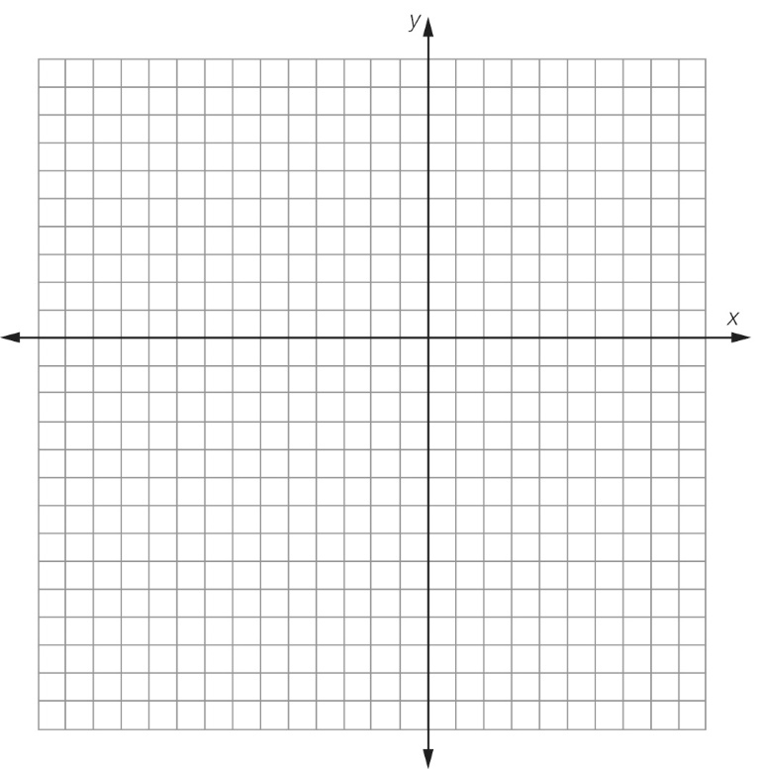

**(c)** Write the coordinates of the turning point.

Question 12 6 marks [9.1]

Consider the parabola (quadratic graph) plotted on the axis below.

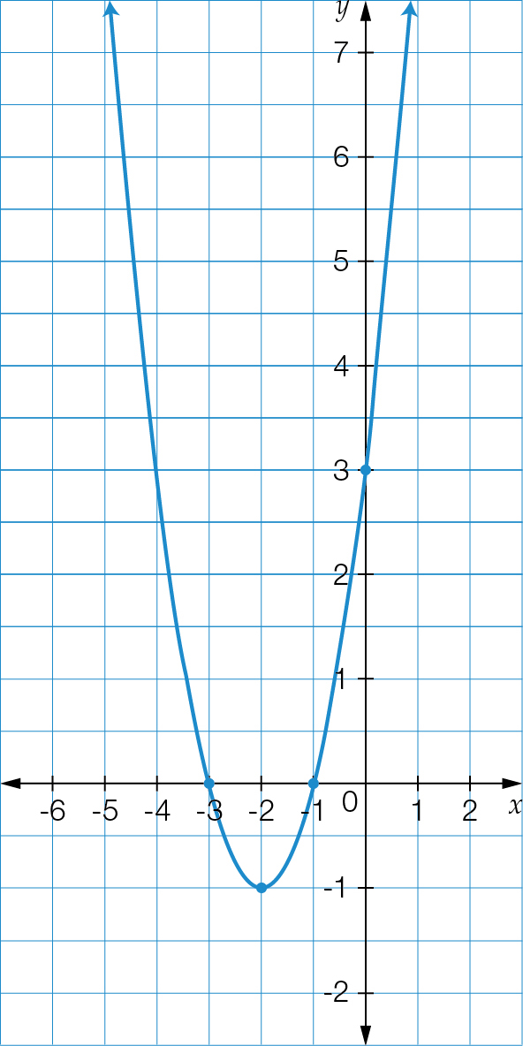

**(a)** What are the coordinates of the turning point for the above graph?

**(b)** Does the parabola have a maximum or minimum turning point?

**(c)** What are the coordinates of the *y*-intercept?

**(d)** What are the coordinates of the two *x*-intercepts?

**(e)** What is the equation of the axis of symmetry?

Question 13 3 marks [9.2]

Solve the following equations using the null factor law.

**(a)**  (*x* – 2)(*x* + 5) = 0

**(b)** *x*2 – 7*x* = 0

**(c)** *x*2 – 121 = 0

Question 14 5 marks [9.2]

Solve the following equations using the null factor law.

**(a)** *x*2 – 7*x* + 12 = 0

**(b)** *x*2 + 3*x* = 28

**(c)** *x*2 – 8*x* + 16 = 0

Question 15 4 marks [9.3]

For the following pairs of parabolas, state the transformations (changes) that have be made to the graph of *y* = *x*2 (solid line) to obtain the new graph (dotted line).

|  |  |  |
| --- | --- | --- |
| **(a)**  ExFAT:Pearson chapter tests:_SUPPLIED_V1_CORREX_080916:_SUPPLIED_V1_CORREX_080916:PM2e_09_EB_09_FBT_02.jpg | **(b)** ExFAT:Pearson chapter tests:_SUPPLIED_V1_CORREX_080916:_SUPPLIED_V1_CORREX_080916:PM2e_09_EB_09_FBT_03.jpg | **(c) ExFAT:Pearson chapter tests:_SUPPLIED_V1_CORREX_080916:_SUPPLIED_V1_CORREX_080916:PM2e_09_EB_09_FBT_04.jpg** |

**(a)** The graph *y* = *x*2 has been translated **\_\_\_\_\_\_\_\_\_\_\_\_\_\_\_\_\_\_\_\_\_\_\_\_\_\_\_\_\_\_\_\_\_\_\_\_\_\_\_\_\_\_\_\_\_\_\_.**

**(b)** The graph *y* = *x*2 has been \_\_\_\_\_\_\_\_**\_\_\_\_\_\_\_\_\_\_\_\_\_\_\_\_\_\_\_\_\_\_\_\_\_\_\_\_\_\_\_\_\_\_\_\_\_\_\_\_\_\_\_\_\_\_\_\_.**

**(c)** The graph *y* = *x*2 has been translated **\_\_\_\_\_\_\_\_\_\_\_\_\_\_\_\_\_\_\_\_\_\_\_\_\_\_\_\_\_\_\_\_\_\_\_\_\_\_\_\_\_\_\_\_\_\_\_\_**

and \_\_\_\_\_\_\_\_\_\_\_\_\_\_\_\_\_\_\_\_\_\_\_\_\_\_\_\_\_\_\_\_\_\_.

Question 16 5 marks [9.4]

Determine the centre and radius of the following circle and hence the equation of the circle.

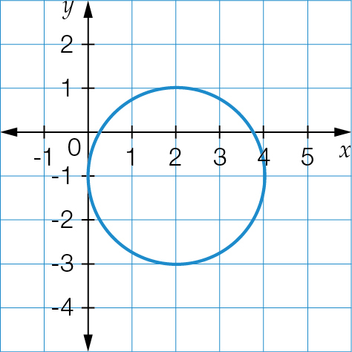

Remember: the equation of a circle is (*x* – *h*)2 + (*y* – *k*)2 = *r*2.

*h* = \_\_\_\_\_\_\_, *k* = \_\_\_\_\_\_\_, *r* = \_\_\_\_\_\_\_, centre: \_\_\_\_\_\_\_\_\_\_\_\_\_\_\_\_\_\_

equation: \_\_\_\_\_\_\_\_\_\_\_\_\_\_\_\_\_\_\_\_\_\_\_\_

Question 17 3 marks [9.5]

Consider the following graph.

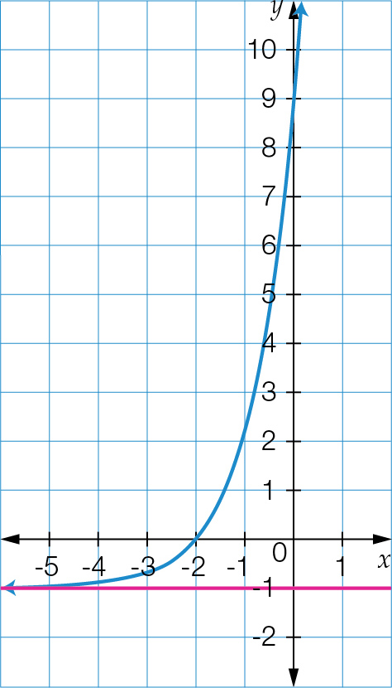

**(a)** What type of relationship does this graph represent?

**(b)** What is the value of the *y*-intercept for this graph?

**(c)** What is the name of the horizontal line passing through *y* = -1?

Question 18 4 marks [9.5]

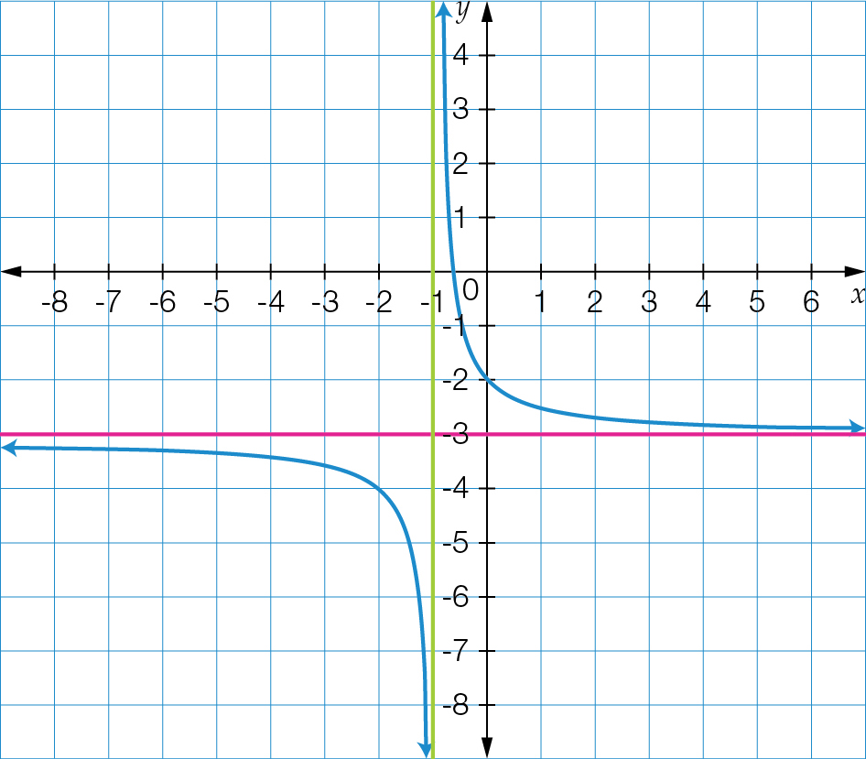

**((a)** What is the name of the relationship that is represented by this graph?

**(b)** Use *a* = 1 and the general equation *y* =  + *k* to determine the equation of the graph.

**(c)** State the value of the horizontal and vertical asymptotes.

Question 19 4 marks [9.6]

Consider the following table:

|  |  |  |  |  |
| --- | --- | --- | --- | --- |
| *x* | 2 | 5 | 9 |  |
| *y* | 12 |  | 54 | 66 |

**(a)** Circle the correct description of the relationship between *x* and *y*.

*y* is directly proportional to *x* OR *y* is inversely proportional to *x*

**(b)** Find the constant of proportionality *k* for this relationship.

**(c)** Use your value for *k* to find the missing values in the table.

Short answer results: \_\_\_ / 41

Extended answer section

Question 20 10 marks [9.1]

A ball is thrown. It follows a parabolic path where its height above the ground (*h* metres) at any time (*t* seconds) is given by the relationship *h* = -4*t*2 + 16*t.*

**(a)** Complete the table of values for this relationship.

|  |  |  |  |  |  |
| --- | --- | --- | --- | --- | --- |
| *t* | 0 | 1 | 2 | 3 | 4 |
| *h* |  |  |  |  |  |

**(b)** Plot the graph of this relationship clearly showing:

**(i)** the turning point

**(ii)** *x*-intercepts

**(iii)** *y*-intercept.

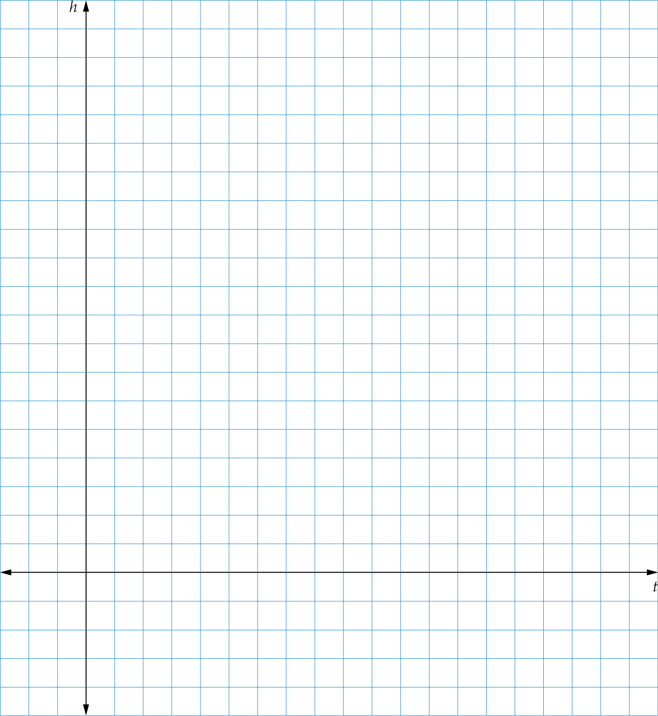

**(c)** What is the maximum height of the ball?

**(d)** At what time does the ball reach its maximum height?

**(e)** When does the ball hit the ground?

**(f)** When is the ball 12m from the ground?

Question 21 16 marks [9.4]

A circle has the equation (*x* – 1)2 + (*y* + 2)2 = 49.

**(a)** Determine the coordinates for the centre of the circle.

**(b)** What is the radius of the circle?

**(c)** Use the maximum and minimum values of *x* and *y* to find four points on the circle in line with the centre horizontally and vertically.

*x* min: \_\_\_\_\_\_\_\_\_\_,  *x* max: \_\_\_\_\_\_\_\_\_\_, *y* min: \_\_\_\_\_\_\_\_\_\_, *y* max: \_\_\_\_\_\_\_\_\_\_

Point A: (\_\_\_\_\_\_\_\_,\_\_\_\_\_\_\_\_\_), Point B: (\_\_\_\_\_\_\_\_,\_\_\_\_\_\_\_\_\_),

Point C: (\_\_\_\_\_\_\_\_,\_\_\_\_\_\_\_\_\_), Point D: (\_\_\_\_\_\_\_\_,\_\_\_\_\_\_\_\_\_),

**(e)** Using the information found in **(a)** to **(c),** sketch the circle showing all relevant point.

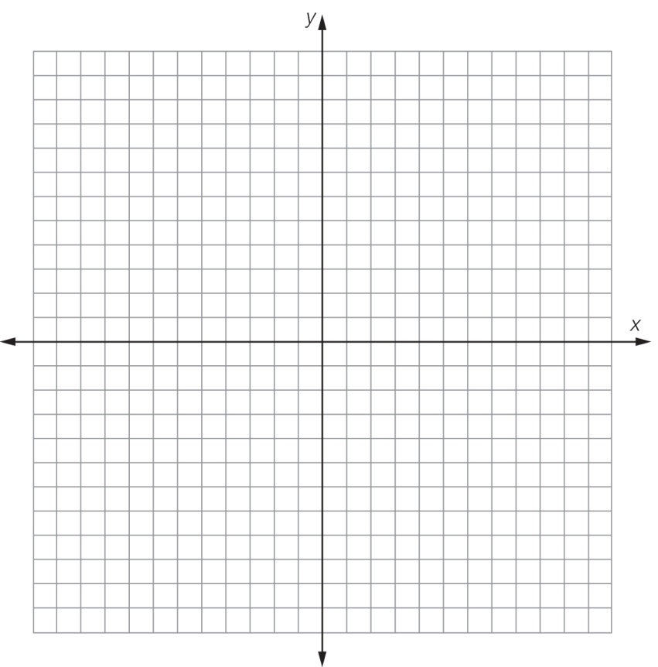

**(f)** Determine whether the following points are inside or outside the circle.

**(i)** (2, 4)

**(ii)** (-5, 3)

**(iii)** (8, 2)

**(iv)** (3, 4)

Question 22 6 marks [9.7]

Consider the table of values:

|  |  |  |  |  |
| --- | --- | --- | --- | --- |
| *x* | 1 | 2 | 3 | 5 |
| *y* | 30 | 15 | 10 | 6 |

**(a)** Explain why the relationship between *x* and *y* is inversely proportion.

**(b)** What is the value of the constant of proportionality *k*?

**(c)** Express the relationship between the two quantities *x* and *y* as an equation.

**(d)** Graph the relationship between *x* and *y,* placing *x* on the horizontal axis and *y* is on the vertical axis.

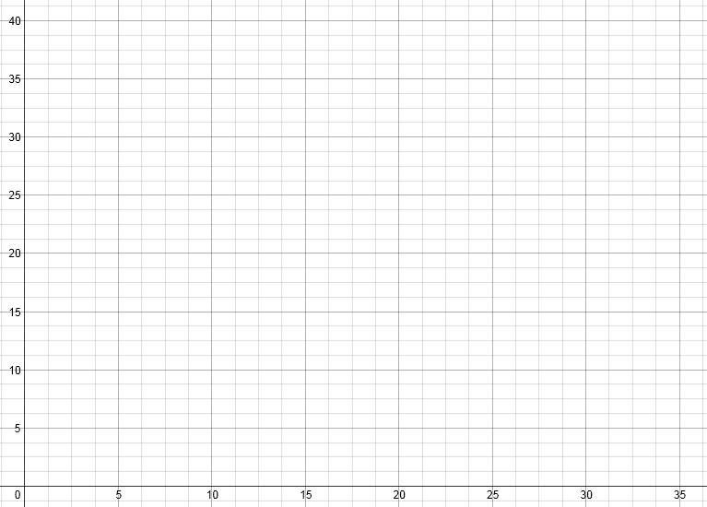

**(e)** What is the value of *y* where *x* = 30?

Extended answer results: \_\_\_ / 32

TOTAL test results: \_\_\_ / 83